SUSTAINABLE SWANSEA AWARDS 2012

Project Report

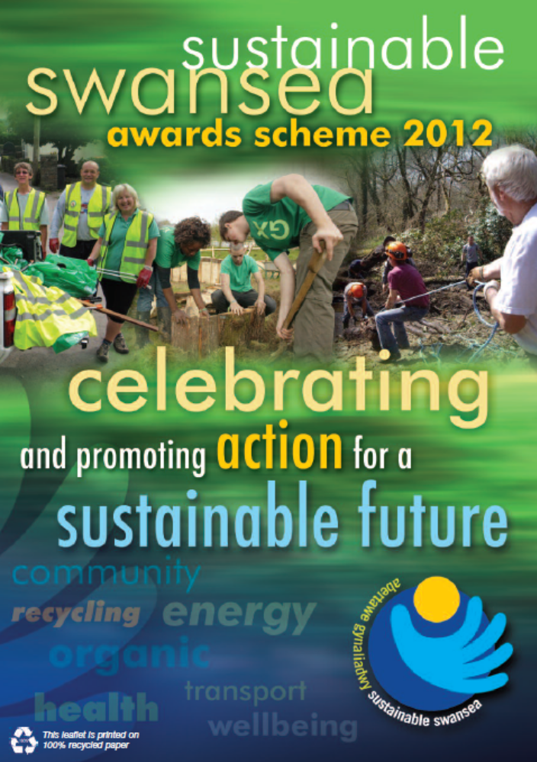
_____________________________________________________________________________

Scheme Co-ordinator / Report Author: Philip McDonnell
PMDevelopments
01792 898423
swanseapmd@aol.com

Contents

Background 3

Project Aims and Objectives 4

Award Categories 4

Sponsorship and Support 6

Project Finances 6

Launch Event and Promotion 7

Application Process 7

Assessment Process 8

Awards Dinner and Presentation Ceremony 9

Project Evaluation 9

Appendix 1: List of Award Finalists and Winners 10

Appendix 2: Results of Project Evaluation Surveys 11

Appendix 3: Articles in South Wales Evening Post 12

Background

The Sustainable Swansea Awards Scheme recognises, rewards and promotes the achievements of local organisations, groups and individuals that have made an active commitment to good environmental practice and sustainable development.

Taking a sustainable approach to projects or the way organisations are managed is about ensuring that we can enjoy a good quality of life and that the environment, economy and society are thriving and healthy, both now and for the future.

The first awards took place in 2005 and again in 2006, and then the scheme became biennial with a third round taking place in 2008 and a fourth round in 2010.

The Awards Scheme is a key element of the Sustainable Swansea initiative that is coordinated by Swansea Environmental Forum (SEF) on behalf of a broader partnership with The Environment Centre, the City and County of Swansea and Swansea CVS.

Sustainable Swansea Initiative
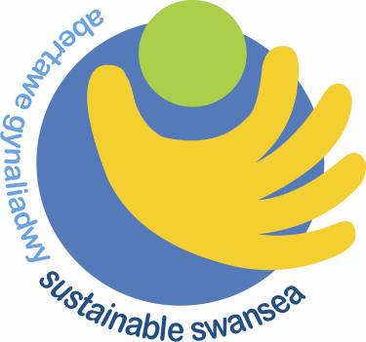
The Sustainable Swansea Initiative aims to make a significant and long-lasting contribution to making Swansea a more sustainable place to live, work and visit.

It raises awareness and understanding of sustainability, demonstrates good practice, and seeks to effect change in the attitudes and behaviour of people in communities across Swansea; providing resources, information and enthusiasm for sustainable living.

The Sustainable Swansea Initiative supports and contributes to the delivery of Swansea’s Community Strategy and Swansea Environment Strategy.

Swansea Environmental Forum (SEF)

SEF is the strategic partnership for all aspects of the natural and built environment in Swansea and the lead body for the environmental aspects of the Community Strategy.

Set-up in 1985, SEF is a fully constituted voluntary group with membership open to individuals and organisations that support its mission to promote and facilitate environmental sustainability in Swansea.

SEF recognises that the protection and enhancement of the environment is best achieved by working together in the context of sustainability. The principles of sustainable development are therefore at the heart of the Forum's work.
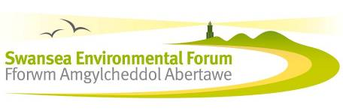
Project Aims and Objectives

Aim
To recognise, reward and promote the achievements of local organisations, groups and individuals that make an active commitment to good environmental practice and sustainable development in Swansea

Objectives

- Recognise and reward contributions to making Swansea a more sustainable place to live, work, and visit.
- Promote, publicise and raise awareness of sustainability across all sectors.
- Highlight best practice in sustainability.
- Reward and encourage innovation and continual improvement.
- Encourage cross-sector networking and collaboration.
- Set high standards.
- Celebrate achievements.
- Work in partnership.
- Be open, fair, and accountable.

The Awards Scheme is aimed at organisations and individuals that can demonstrate a commitment to sustainability over and above statutory or general work requirements.

Award Categories

The number and type of award categories has varied over the years – initially based around different sectors e.g. business, community, public agencies, etc. However, a number of new thematic award categories were introduced in 2010 to reflect and draw attention to some of the key priorities of the Forum and its partners.

The eight award categories in the 2012 scheme each aimed to reward a particular type of project, organisation or activity. The same application form was used for seven categories but there was a separate application form for the Champion Award.

Community Project Award – sponsored by The Cooperative Membership

This award category is open to any organisation, community group or partnership that has organised a community-based project which contributes to one or more aspect of sustainability.

Low Carbon Swansea Award – sponsored by Swansea Environmental Forum (with support from Environment Agency Wales)
This award category is open to any organisation, group or partnership that has made significant progress in reducing carbon emissions or promoting low carbon activities.

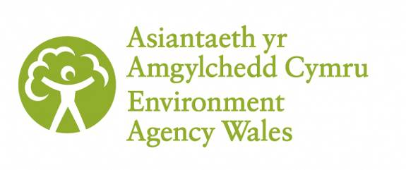
Clear Streams Swansea Award – sponsored by Environment Agency Wales
This new award category is open to any organisation, group or partnership that has contributed to the protection, restoration and/or promotion of a local water body (e.g. river, stream, canal, pond or sea).

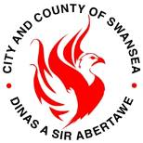
Waste Wise Business Award – sponsored by the City and County of Swansea Recycling Service
This award category was open to any commercial organisation that had made significant improvements in the way it deals with waste e.g. through minimisation, reuse, composting or recycling initiatives.

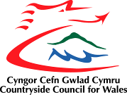
Biodiversity Award – sponsored by Countryside Council for Wales
This award category was open to any organisation, group or partnership that through a project or its activities had made a significant contribution to protecting or enhancing biodiversity.

Built Heritage Award – sponsored by Swansea Environmental Forum
This new award category is open to any organisation, group or partnership that has contributed to the protection, restoration and/or promotion of a historic building or built heritage site in Swansea.


Sustainable Schools Award – sponsored by Swansea Environmental Education Forum
This award category is open to any school or college in Swansea that through a project or its activities has made significant progress in its environmental management and/or the delivery of ESDGC. Progress within the Swansea Sustainable Schools Scheme (4S’s) was taken into account.

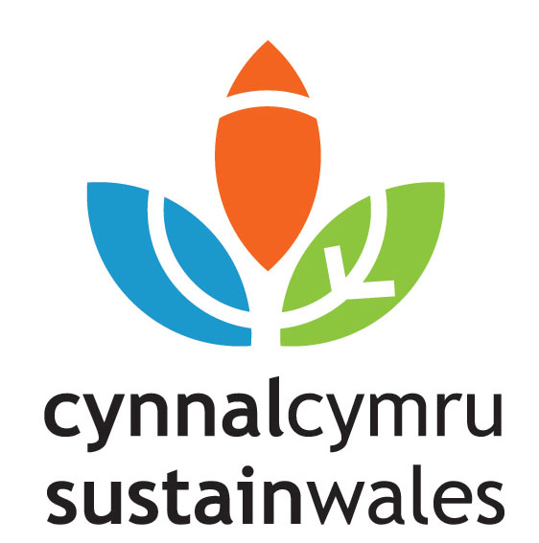
Champion Award – sponsored by Cynnal Cymru-Sustain Wales
This award category was for outstanding individual contribution in a paid or voluntary role either within an organisation or as a committed and proactive citizen of the community. Individuals could nominate themselves or be nominated by a colleague or friend. Applicants to any of the other award categories (1–6) were encouraged to nominate a colleague or associate for the Champion Award. A separate application form was available for this category.

Although an overall winner was chosen in the 2008 awards, it was agreed that this would not be done in the 2010 awards, and likewise in the 2012 awards.

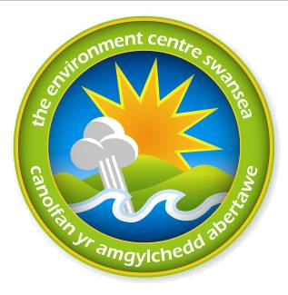
Sponsorship and Support

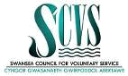
The Awards Scheme was only made possible through the generous financial contributions from the award sponsors (listed above) with additional donations to the scheme in general from Swansea CVS and Environment Agency Wales.

In-kind support was also provided by the Environment Centre and the Co-operative Membership donated wine for the awards ceremony.

Project Finances

The following is an outline of the income and expenditure on the 2012 awards scheme:

Income
Swansea Environmental Forum’s own funds £3,000
Sponsorship and donations £7,950
Award ceremony ticket sales £756
_______
Total income £11,706

Expenditure
Coordination fees £6,450
Promotion and launch £402
Awards and certificates £740
Awards ceremony £3,760
Administration costs £354
_______
Total expenditure £11,706

The total expenditure was almost £1,500 lower than in 2010 with the main saving being on coordination costs (over £1,000 less).

It has also been calculated that almost £2,500 worth was provided as in-kind contributions from the unpaid time given by judges and the project coordinator.
A donation of wine for the award ceremony (worth approximately £150) was also made by the Co-operative Membership.

Launch Event and Promotion

The 2012 Awards were launched at RSPCA Llys Nini, a previous award winner, on 17th September 2012. David Fitzpartick, CEO of Cynnal Cymru-Sustain Wales, gave the formal launch speech and the event was attended by about 50 people including the Deputy Lord Mayor and representatives of sponsors, partners and previous winners.

A promotional flyer was launched at this event and subsequently distributed to all libraries and community development centres, and by partner organisations such as Swansea CVS and the local authority.

Promotional articles were sent to the South Wales Evening Post, the Environment Centre, Swansea CVS, SEEF, Cynnal Cymru and other partners for use in their publications and websites. As well as promoting the Awards at the time of the launch.

After the Awards Dinner and Presentation Ceremony, several articles were published in the Evening Post (see Appendix 3) and several partner organisations carried articles on their websites and in newsletters announcing winners.

Application Process

Applicants to the Award Scheme were required to complete the appropriate application form and meet basic eligibility criteria. Application forms could be accompanied by additional information (up to 1,000 words) and other supporting materials such as photographs, plans, press clippings, etc.

The application forms were designed to be short and simple, in order to encourage participation and minimise the time and resources needed to enter. However, applicants were expected to be thorough, clear and specific in their applications as these were the only basis on which short listing was assessed.

The Application Guidelines that accompanied the applications forms included the following rules and conditions:
- Entry to the Sustainable Swansea Awards Scheme is FREE.
- Applications must be for projects and activities within the City and County of Swansea and must focus on activities / achievements in the last two and a half years (since April 2010).
- Previous applicants and winners are welcome to apply to this year’s awards.
- Award sponsors can apply but not in a category that they are sponsoring.
- An organisation, group or partnership can submit an application for more than one project – in the same award category or different categories – separate forms must be used for each application.
- Applicants must complete ALL PARTS of the appropriate application form – in clear writing.
- Applicants must be able to demonstrate that they are applying good environmental practice and operating to standards required by law, statutory duties and regulations.
- All applications and any supporting materials must be submitted by Friday 16th November 2012.
- The decisions of the judging panel and scheme administrators will be final.

Applications could be submitted by email or post and in either Welsh or English (though none were received in Welsh). On receipt of each application, the Awards Scheme administrator checked that they satisfied the basic requirements (listed above) and sent a confirmation email to the applicant.

In total, the Sustainable Swansea Awards 2012 received and assessed 32 separate applications across the eight award categories from 26 different organisations and 3 individuals. A full list of the finalists short listed for each category is given in Appendix 1.

Assessment Process

Applications were assessed by a panel of judges comprising 16 members with a range of expertise and experience in at least one aspect of sustainability. The eight award category sponsors were invited to provide a representative that would be involved in assessing the applications to the category that their organisation sponsored. Additional judges were also appointed to make up teams of two judges per category. Potential conflicts of interest were discussed and recorded at the first meeting of the judging panel and categories allocated to avoid clashes.

Short Listing and Site Visits

The judging panel as a whole was responsible for the proper and fair assessment of the applications and the selection of finalists and winners. However, the small teams of two judges each took responsibility for short listing applications in one category then reporting back to the full panel. The same teams later visited the short listed applicants and reported back to the full panel with their recommendations regarding their category winner.

The judging teams were provided with a generic assessment scoring system to help with the short listing and site visits but were also invited to amend and add to this as appropriate for their particular award category. Each team was asked to short list up to three applicants – less if they felt the quality of applicants was not high enough and more if they found it too difficult to separate three applicants from the others in their category. Once the whole judging panel had agreed the short listed applicants suggested by each team, then the site visits to the short listed applicants were arranged. The short list was presented to the Executive Committee of Swansea Environmental Forum for endorsement ahead of the winners being determined. This was necessary as this body has overall responsibility for the Sustainable Swansea Initiative and the awards scheme. At this point, the short listed applicants were invited to the award ceremony and designated as award category finalists.

The site visits enabled the judges to delve deeper into the activities of the finalists and ask questions beyond the application form. The judging teams were free to construct a new assessment sheet or prepare a list of core questions to ask during each visit. At the final judging panel meeting, the teams fed back on their visits and suggested a winner.

Statistical comparison of Award years | 2005 | 2006 | 2008 | 2010 | 2012
Number of award categories | 6 | 7 | 7 | 7 | 8
Number of applications received | 51 | 57 | 45 | 41 | 32
Number of finalists shortlisted | 20 | 19 | 21 | 20 | 24
Number of awards presented | 6 | 7 | 8 | 7 | 8

Awards Dinner and Presentation Ceremony

The Awards Dinner and Presentation Ceremony took place on 22nd March 2013 at the Marriott Hotel in Swansea’s Maritime Quarter. Finalists, sponsors and partners were invited to send representatives and several special guests were also invited. In total 120 attended the event. The keynote address was given by Peter Davies, Wales’ Commissioner for Sustainable Futures.

A short slide presentation of the finalists in each category was delivered before the winner announced and awards presented by a representative from the award category sponsor.

Award Trophies

The eight winners’ trophies were created by Ten Green Bottles – a social enterprise based in Powys. Each trophy was handcrafted from 100% recycled glass and mounted on wood from a sustainable source.

Each winner and all the other finalists received a commemorative certificate.

The award winners are shown in Appendix 1.

Project Evaluation

The project evaluation was carried out via two short online questionnaires using SurveyMonkey: one sent to each of the 24 finalists and the other sent to the 16 on the judging panel (representing project sponsors and other partners).

The level of response was good with 30 completing the questionnaire out of the 40 asked (75% response rate). Most respondents to both surveys felt that the scheme as a whole, and the ceremony specifically, were excellent or good and that it was worthwhile being involved (either as an applicant, sponsor or partner). Most also indicated that they were likely to be involved again in the future. The responses to each question were more positive than those given to identical surveys undertaken after the previous awards scheme in 2010.

Two-thirds of the survey respondents added further comments, most of which praised the awards scheme organisation, the ceremony and the venue. Other comments suggested the need for better marketing and making the scheme bilingual.

The full results of the surveys are shown in Appendix 2.

“the awards ceremony was very impressive and I felt very valued”

“we found it well organised and a great showcase for the work going on in Swansea”

“an extremely worthwhile experience”

Appendix 1: List of Award Finalists and Winners

Number of categories: 8 Total number of applicants: 32

Community Project Award – number of applications: 6
Vetch Veg AWARD WINNER
Gower Walking Festival
Woodland Walk (Vale Europe Ltd)
Penllergare Trust
Low Carbon Swansea Award – number of applications: 6
Morgan AM&T AWARD WINNER
CEMARS Initiative (S&C Electric Europe Ltd)
Positive Energy (Groundwork)
Built Heritage Award – number of applications: 3
Henbury Cottage AWARD WINNER
Llandeilo Talybont Churchyard
Llys Glas
Waste Wise Business Award – number of applications: 3
Zero Landfill (S&C Electric Europe Ltd) AWARD WINNER
Towards Zero Waste (Lorien Business Services)
Down to Earth Project
Clear Streams Swansea Award – number of applications: 4
Swansea Canal Society AWARD WINNER
Swansea Misconnection Project
Nature Days
Biodiversity Award – number of applications: 3
Crwys Community Woodland AWARD WINNER
Torgoch (Commons Vision L td)
RSPB Cwmclydach Kites & Dippers
Sustainable Schools Award – number of applications: 4
Bishopston Comprehensive School AWARD WINNER
Birchgrove Comprehensive School
Champion Award – number of applications: 3
Michael Norman (Penllergare Trust) AWARD WINNER
Sally Hyman (RSPCA Llys Nini)
Ben Rees (RSPB Cwmclydach)

Appendix 2: Results of Project Evaluation Surveys

Finalists Survey – number of surveys completed: 18 (out of possible 24)

1. How would you rate the Sustainable Swansea Awards 2012 as a whole?
excellent: 15 (83%) good: 3 (17%) okay: 0 poor: 0

2. How would you rate the Awards Ceremony specifically?
excellent: 15 (83%) good: 3 (17%) okay: 0 poor: 0

3. Do you feel it was worthwhile your organisation submitting an application this year?
very worthwhile: 7 (78%) worthwhile: 3 (22%) not worthwhile: 0

4. How likely is it that your organisation will submit an application to the Awards Scheme in the future?
very likely: 14 (78%) possible: 3 (17%) unlikely: 1 (5%)

5. Do you have any further comments or suggestions for improving the Awards Scheme?
Total number of comments made: 14
- more information and press release on the finalists before the awards dinner
- great event, well organised, good communication, really good project summaries
- more publicity to attract entrants
- balance of formality and a relaxing, rewarding ceremony achieved
- venue and food was of a high standard
- have name of organisation on the certificates
- post-awards opportunity for finalists to meet to discuss their projects in more detail
- we were kept informed throughout the entire process and the award ceremony was brilliant
- we found it well organised and a great showcase for the work going on in Swansea
- the awards ceremony was very impressive and I felt very valued
- a really professional award scheme

Sponsors, Partners & Judges Survey – surveys completed: 12 (out of possible 16)

1. How would you rate the Sustainable Swansea Awards 2012 as a whole?
excellent: 9 (75%) good: 3 (25%) okay: 0 poor: 0

2. How would you rate the Awards Ceremony specifically?
excellent: 8 (73%) good: 3 (23%) okay: 0 poor: 0 (1 skipped)

3. Do you feel that it was worthwhile for your organisation to sponsor or support the Awards Scheme this year?
very worthwhile: 9 (75%) worthwhile: 3 (25%) not worthwhile: 0

4. How likely is it that your organisation will offer sponsorship or support for the Awards Scheme in the future?
very likely: 7 (58%) possible: 5 (42%) unlikely: 0

5. Do you have any further comments or suggestions for improving the Awards Scheme?
Total number of comments made: 6
- give it wider publicity in the run-up to the awards to maximise number and quality of entrants.
- Marriott was a good venue - definitely should use again.
- an extremely worthwhile experience; puts Swansea ahead of many other local governments when it comes to sustainability!
- ongoing necessity to always question and refine categories simply to make judging easier
- need a major communications partner.
- fingers crossed the new environmental body Natural Resources Wales will understand the value of the awards and be able to sponsor an award
- make it bilingual – social/cultural sustainability is important.

Appendix 3: Articles in South Wales Evening Post

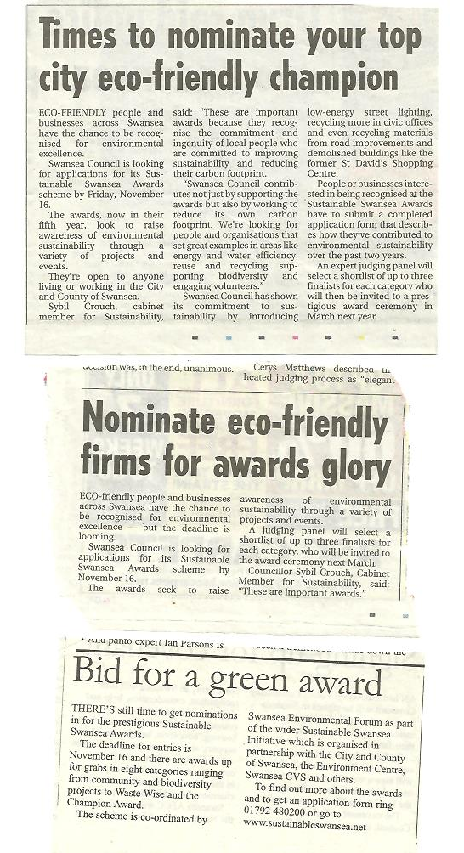

Three short articles in the Evening Post promoting the launch of the award scheme.

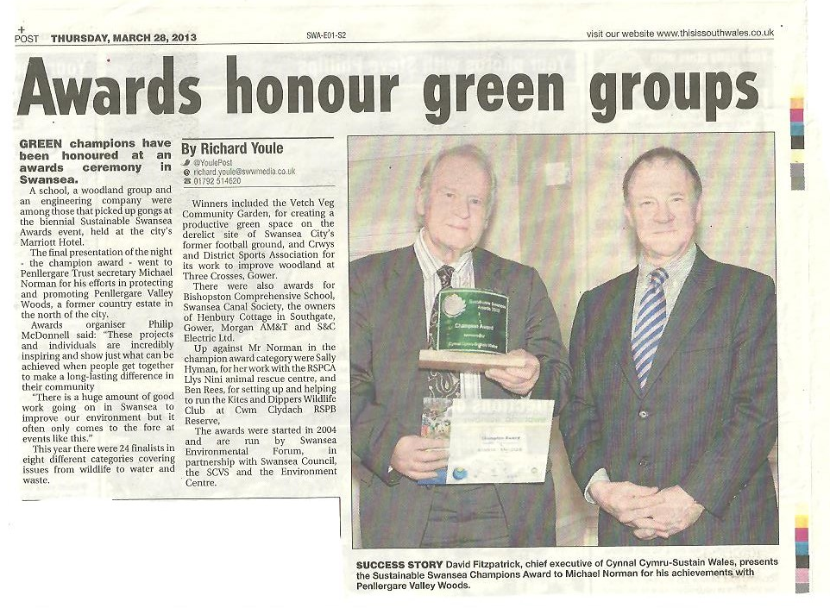

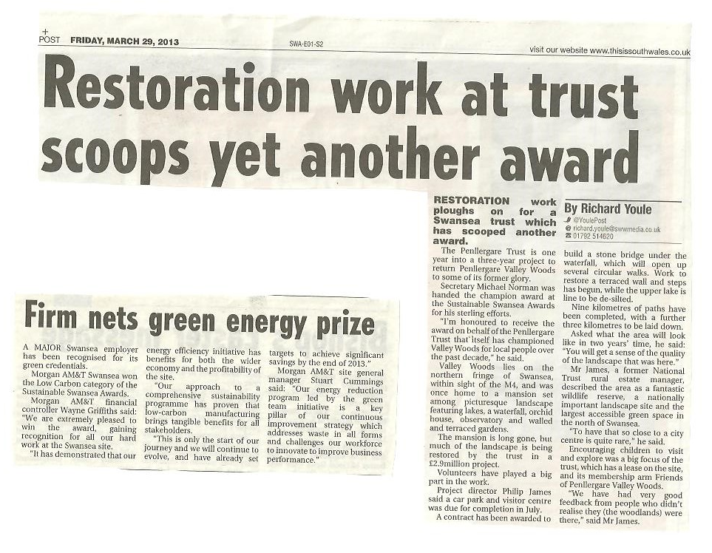

Two articles relating to Michael Norman (Penllergare Trust) receiving the Champions Award
and a short article about Morgan winning the Low Carbon Swansea Award.

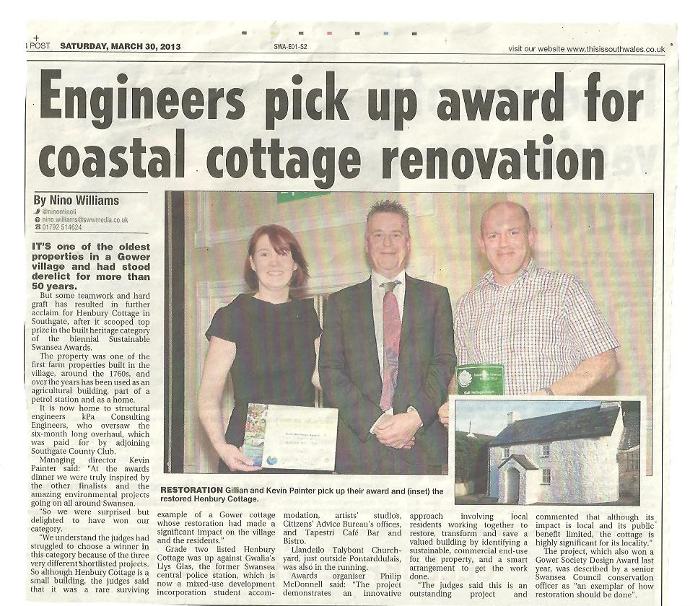

Article about Henbury Cottage winning the Built Heritage Award.

Swansea Canal Society land another award
Friday, April 05, 2013
SWANSEA Canal Society is celebrating after winning the Clean Streams category in the Sustainable Swansea Awards. The gong comes just months after the group was presented with an annual Volunteer Recognition Award by Glandwr Cymru — the Canal & River Trust in Wales.
The society is one of a number of volunteer groups whose work has helped to transform stretches of waterways in Wales. And there is no rest for volunteers, who are planning their next outing to clean up a stretch of the canal later this month.
They will be meeting at Lower Trebanos Lock, by the Green Farm riding stables, on April 24, from 1pm, and working their way up the canal to Pontardawe clearing litter.

Article about Swansea Canal Society winning the Clear Streams Swansea Award
(taken from the This Is South Wales website).

